**Class:** Final Year (Computer Science and Engineering)

**Year:** 2021-22 **Semester:** 1

**Course: High Performance Computing lab**

**ESE Exam**

**22/11/2021 01.00 PM – 04.00 PM**

**Exam Seat No:**

Name: Manmath Bhale

Exam Seat Number: 2018BTECS00049

**Problem Statement 1:** Implement following OpenMP clauses.

Single() Ordered() Barrier()

**Screenshot 1:**

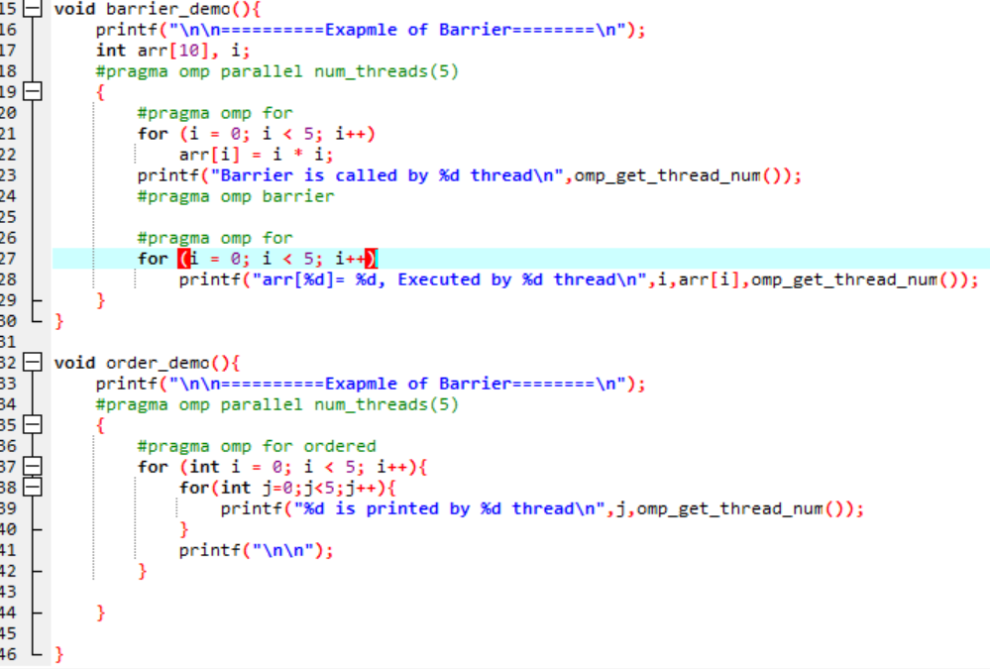

**Information 1:** Code for order and Barrier clause

**Screenshot 2:**

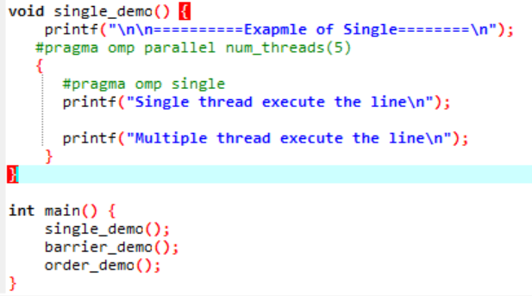

**Information 2:** Code for Single clause and main function.

**Output:**

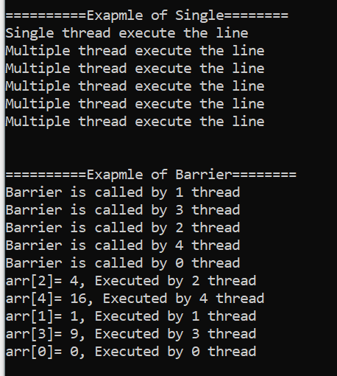

**Output :**

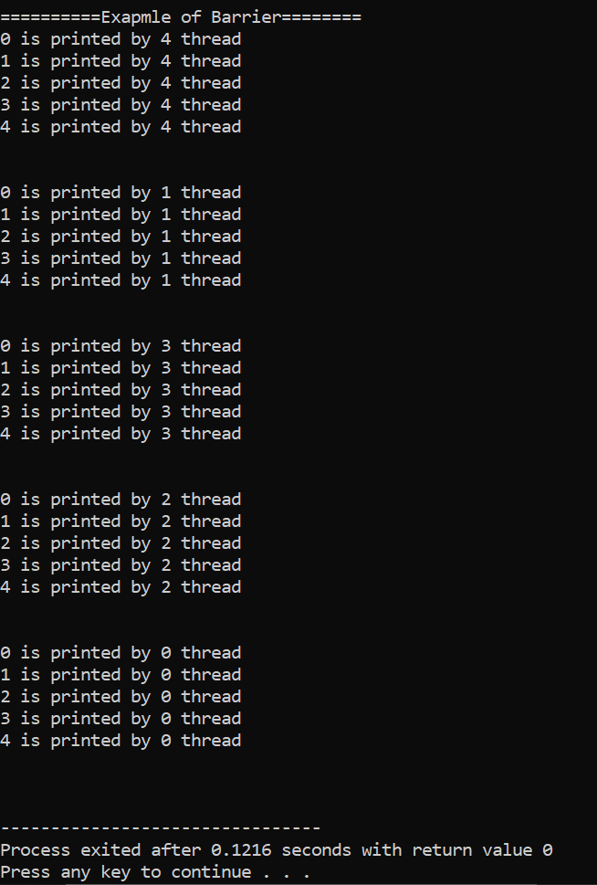

**Problem Statement 2:** Implement MPI program to send float array from one process to other.

**Screenshot 1:**

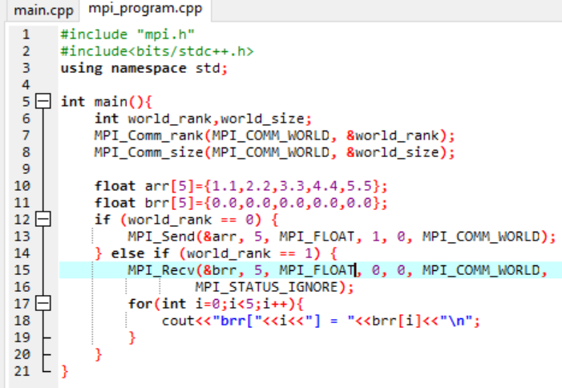

**Information 1:** Cpp code for sending float array from one process to other process.

**Problem Statement 3:** Find Factorial of a number using CUDA.

**Screenshot 1:**

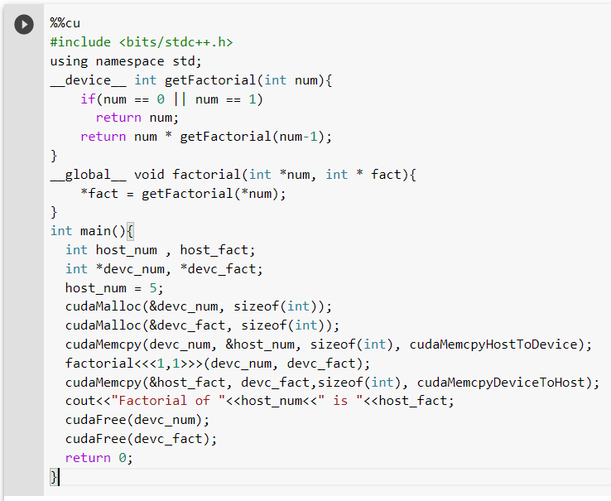

**Information 1:** CUDA code for finding factorial of a number

**Screenchot 2:** Output for n=5

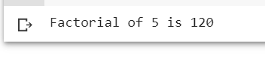

**Google Colab Link :** <https://colab.research.google.com/drive/1mQrJ_8je1pShWUxWk6W5QYbMImkg7-cS?usp=sharing>

**Technologies Used:** Openmp , MPI , CUDA on google colab.

**GitHub Link:** <https://github.com/manmath315/HPC-LAB>